1. **1: Create a blank file named “myfile”**

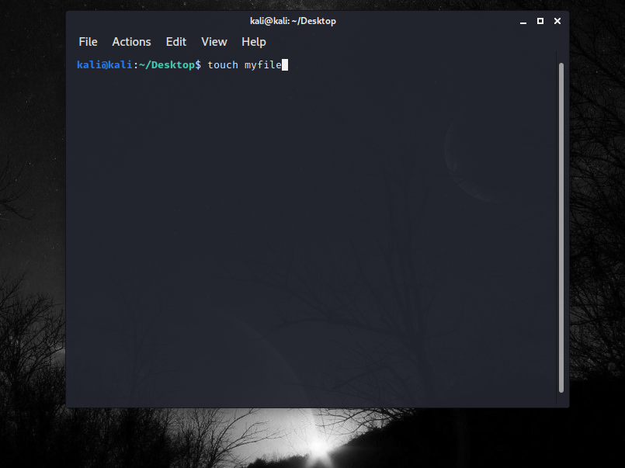

1. **2: Open “myfile” in vi editor**

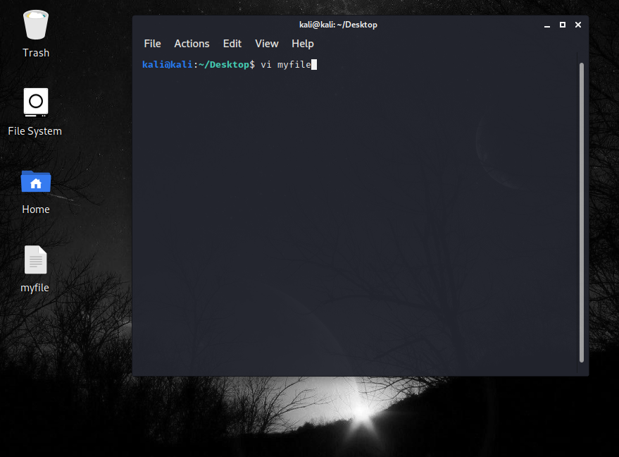

1. **3: Write your name, address, email id, phone number and blood group in 5 different lines**
2. 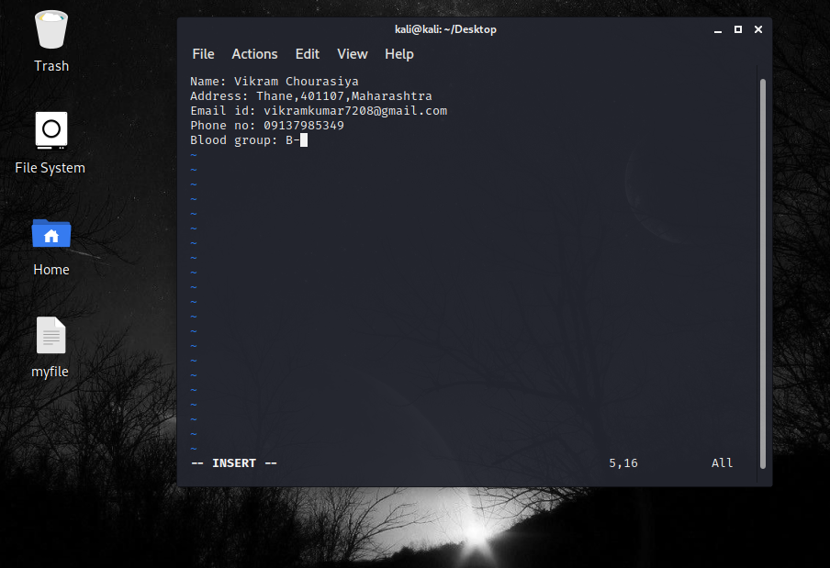**4: Build one single expression to see the line with your name and blood group in myfile**

